## SUMMER INTERNSHIP PROJECT REPORT ON

Integrated Hybrid Video Compression Framework using Machine Learning

*By:*

Abhishek Kasina *(621161)*

Midde Sai Sumanth Royal *(621213*)

Vislavath Vinod Nayak (621271)

INSTRUCTOR: ***Dr. Mohammad Farukh Hashmi***



## DEPARTMENT OF ELECTRONICS AND COMMUNICATION ENGINEERING

NATIONAL INSTITUTE OF TECHNOLOGY WARANGAL

TABLE OF CONTENTS

Acknowledgmet……….…………………………………………………… 3

Abstract…..………………………………………………………………… 3

Keywords…………………………………………………………………... 3

1.0 Introduction…………………………………………………………….. 4

2.0 Literature Review………………………………………………………. 5

#### 2.1 TraditionalTechinque……………………………………………. 5

2.2 Advanced Video Coding Standards……………………………... 6

3.0 Block Diagram and Description of blocks……………………………….. 8

4.0 Dataset Description……………………………………………………… 9

5.0 Methodology…………………………………………………………… 11

6.0 Workflow……………………………………………………………….. 13

7.0 Results…………………………………………………………………... 15

8.0 Conclusion………………………………………………………………. 19

9.0 References………………………………………………………………. 21

ACKNOWLEDGMENT

We owe a lot to **Dr. Mohammad Farukh Hashmi**, our supervisor, especially for the support and skill he exhibited as our supervisor in this entire process. Moreover, his input was invaluable not only in shaping the direction that this work has taken but also making sure that it went on smoothly.

ABSTRACT

Video compression plays a pivotal role in managing the storage and transmission of multimedia content, especially in bandwidth-constrained environments. This project presents an integrated hybrid video compression framework that combines traditional techniques such as motion estimation and Discrete Cosine Transform (DCT) coding with machine learning methodologies. The framework aims to improve compression efficiency and maintain high-quality video output through intelligent prediction and optimization.

The project utilizes the UCF101 dataset, a widely used benchmark for action recognition in videos, to validate and train machine learning models integrated into the compression pipeline. By leveraging the dataset's diverse set of video clips covering 101 action categories, the framework incorporates machine learning for tasks such as enhancing motion estimation accuracy and optimizing compression strategies based on learned patterns.

KEYWORDS

Integrated hybrid video compression framework, motion estimation, DCT coding, machine learning, UCF101 dataset, efficient video processing

**1.0 Introduction**

Video compression is crucial for making videos easier to store, send, and stream across different uses. This project introduces an advanced hybrid approach to compression that combines classic methods like motion estimation and Discrete Cosine Transform (DCT) with modern machine learning techniques. The goal is to significantly boost how efficiently videos are compressed while also improving the quality of the compressed video.

Traditional techniques like DCT transform video data into frequency coefficients, then reduce unnecessary details through quantization. Motion estimation predicts how objects move between frames, cutting down on repeated information and making compression more efficient.

By adding machine learning into the mix, the framework becomes smarter and more adaptive. Models trained on datasets like UCF101 help predict motion more accurately and adjust compression settings based on what the system learns about video content and its complexities. This approach aims not just for higher compression rates, but also ensures that the compressed videos look great and meet high standards of visual quality.

Combining these traditional and cutting-edge methods, this framework aims to push the boundaries of video compression technology. It's designed to meet the growing demand for delivering multimedia content efficiently across a wide range of digital platforms and applications.

### 2.0 Literature Review

Video compression is vital for efficiently storing, transmitting, and streaming video content across various applications. This section reviews current literature and methodologies in video compression, focusing on traditional techniques such as motion estimation and Discrete Cosine Transform (DCT), as well as recent advancements integrating machine learning.

#### 2.1 Traditional Techniques

**Motion Estimation:** Motion estimation algorithms, including Full Search Motion Estimation and Block Matching Algorithms (BMA), are essential for predicting how objects move between frames in video compression. Full Search Motion Estimation meticulously evaluates potential motion vectors within a specified search window, ensuring accurate motion prediction at the cost of increased computational complexity. On the other hand, BMA divides frames into blocks, comparing each block in the current frame with corresponding blocks in a reference frame to estimate motion efficiently. These techniques significantly enhance compression efficiency by minimizing redundancy and optimizing bitrate allocation, thereby improving overall compression system performance.

**Discrete Cosine Transform (DCT):** The Discrete Cosine Transform (DCT) is a cornerstone of video compression, converting spatial video data into frequency coefficients. Applied to blocks of pixels, DCT decorrelates spatial information and reduces redundancy by concentrating signal energy into fewer coefficients. Following DCT, quantization scales down and rounds coefficients to decrease data precision, impacting compression quality and bitrate. Higher quantization levels lead to smaller file sizes but may introduce perceptible artifacts due to loss of detail, necessitating a balance between quality and efficiency in video coding standards such as MPEG and H.264/H.265.

**Quadtree Decomposition:** Quadtree decomposition partitions frames adaptively into variable-sized blocks based on content complexity, a technique used in modern video compression. It recursively divides frames until meeting a criterion like uniformity of pixel values, enabling the encoder to allocate more bits to detailed or active regions and fewer bits to smoother areas. This method enhances compression efficiency by capturing spatial variations more effectively than fixed-size blocks, preserving visual quality in dynamic scenes. Quadtree decomposition is integral to standards like H.264/AVC and H.265/HEVC, contributing significantly to their effectiveness in reducing data redundancy and enhancing compression performance.

**Conclusion:**

The review highlights the critical role of traditional video compression techniques—motion estimation, Discrete Cosine Transform (DCT), and quadtree decomposition—in optimizing video storage, transmission, and streaming across diverse applications. These methods continue to evolve alongside advancements in machine learning, promising further enhancements in compression efficiency and perceptual quality for future video coding standards and technologies.

**2.2 Advanced Video Coding Standards:**

1. **H.264/AVC:** H.264/AVC (Advanced Video Coding) introduced several key features that revolutionized video compression. It implemented variable block-size motion compensation, allowing different block sizes (e.g., 16x16, 8x8) for more precise motion prediction. This flexibility improved compression efficiency by adapting block sizes to different types of motion within frames. Context-adaptive binary arithmetic coding (CABAC) enhanced entropy coding efficiency by dynamically adjusting coding contexts based on local information, improving compression ratios. The deblocking filter in H.264/AVC reduced artifacts at block boundaries, enhancing visual quality by smoothing out discontinuities between adjacent blocks.
2. **H.265/HEVC:** H.265/HEVC (High Efficiency Video Coding) builds upon H.264 by focusing on further enhancing coding efficiency. It achieves better compression ratios without sacrificing quality, making it suitable for high-resolution video applications up to 8K. HEVC introduces improved intra prediction modes to handle spatial redundancy more effectively, reducing bitrate requirements for static scenes. This standard optimizes encoding complexity and bitrate allocation, providing significant improvements in video quality at lower bitrates compared to H.264.

**Quality Assessment Metrics:**

**Quality assessment metrics** evaluate the fidelity and perceptual quality of compressed videos:

* **PSNR (Peak Signal-to-Noise Ratio)** measures fidelity by quantifying the difference between original and compressed frames in terms of noise introduced during compression. Higher PSNR values indicate less perceptible distortion.
* **SSIM (Structural Similarity Index)** assesses structural similarity between images, considering luminance, contrast, and structure. It correlates well with human perception and is sensitive to artifacts introduced during compression.
* **VMAF (Video Multi-method Assessment Fusion)** integrates multiple quality metrics into a unified score, considering perceptual aspects of video quality. It takes into account human visual sensitivity to artifacts and provides a comprehensive evaluation of video quality.

**Recent Advances and Emerging Trends:**

Recent advancements in video compression are driven by:

* **Deep learning-based techniques**, which use neural networks for improved prediction and compression efficiency. These methods optimize encoding parameters and enhance adaptive bitrate streaming, tailoring video compression to content characteristics dynamically.
* **Perceptual video coding**, which prioritizes preserving subjective perceptual quality over traditional error metrics. By considering human visual sensitivity to artifacts, these approaches aim to enhance viewer experience in multimedia applications.

Challenges such as computational complexity and adapting to diverse content types present opportunities for innovation in adaptive streaming and immersive media applications. Future developments are expected to further enhance video compression efficiency and perceptual quality, catering to evolving multimedia demands.

This overview highlights how advancements in video coding standards and quality assessment metrics are shaping the landscape of video compression, paving the way for improved multimedia experiences across various platforms and applications.

Top of Form

Bottom of Form

**3.0 Block diagram And Description of Blocks :**

**Block diagram:**

Discrete Cosine Transform

Motion Estimation

Video Input

Compressed Video

Recent Advances

Quality Assessment

Deblocking Filter

Quantization

Entropy Coding

**Description of Blocks:**

1. Video Input: Raw video frames are fed into the compression pipeline.

2. Motion Estimation (Block Matching): Determines motion vectors between consecutive frames to predict motion.

3. Discrete Cosine Transform (DCT): Converts spatial data into frequency coefficients.

4. Quantization: Reduces precision of DCT coefficients to achieve compression.

5. Entropy Coding (CABAC/CAVLC): Applies context-adaptive binary arithmetic coding or context-adaptive variable-length coding to further reduce data size.

6. Deblocking Filter: Smooths block artifacts at compression boundaries.

7. Quality Assessment (PSNR, SSIM, VMAF): Evaluates compressed video quality using objective metrics and perceptual evaluation.

8. Recent Advances (Deep Learning, Perceptual Coding): Incorporates recent research trends such as deep learning-based optimization and perceptual video coding.

9. Compressed Video: Final output of the compression process, ready for storage or transmission.

**4.0 Dataset Description:**

The UCF101 dataset is a widely used benchmark dataset in the field of action recognition and video analysis. Here’s a description of the UCF101 dataset:

Overview:

* **Name**: UCF101 (University of Central Florida 101)
* **Purpose**: Action recognition in videos
* **Size**: Contains 13,320 video clips from 101 action categories
* **Format**: Videos are typically in AVI format with varying resolutions and frame rates
* **Annotation**: Each video is labeled with one of the 101 action categories
* **Source**: Compiled from YouTube videos and augmented with human-labeled annotations

**Key Features:**

1. **Action Categories**: Covers a diverse set of human actions including sports, daily activities, and interactions.
2. **Variability**: Videos vary in terms of lighting conditions, backgrounds, viewpoints, and motion patterns, making it challenging for action recognition algorithms.
3. **Training and Testing Sets**: Typically divided into three splits for training, validation, and testing to facilitate model development and evaluation.
4. **Temporal Extent**: Videos range in duration from a few seconds to a minute, capturing the entire action sequence.
5. **Annotations**: Each video clip is annotated with a single ground-truth action label, allowing for supervised learning approaches in action recognition tasks.

**Usage:**

* **Research**: Used extensively for benchmarking new action recognition algorithms, evaluating model performance, and comparing different approaches.
* **Applications**: Supports applications in human-computer interaction, video surveillance, automated sports analysis, and more.

**Challenges:**

* **Variability in Data**: Wide variation in video quality, resolution, and recording conditions challenges model generalization.
* **Complexity of Actions**: Some actions may exhibit subtle variations or occur in cluttered backgrounds, requiring robust feature extraction and recognition techniques.

**Citation:**

If you use the UCF101 dataset in your research or applications, it's customary to cite the original papers or sources that introduced and described the dataset. This helps acknowledge the creators and maintain transparency in research.

**5.0 Methodology:**

The methodology described here outlines a comprehensive approach to video compression, blending traditional techniques with advanced methods to optimize storage, transmission, and streaming of video content.

**Methodology Outline:**

1. **Input Video Loading:**
   * **VideoReader Initialization:** Begins by loading a video file (fileName) to facilitate subsequent frame-by-frame processing.
2. **Parameter Initialization:**
   * **Parameter Definition:** Crucial parameters like blockSize, searchWindow, Thresh, and Qscale are defined. These parameters govern processes such as motion estimation, block-based processing, and quality enhancement through Discrete Cosine Transform (DCT) and quantization.
3. **Video Processing Loop:**
   * **Frame Iteration:** Processes each frame within a specified range (frameStart to frameEnd).
   * **Frame Preprocessing:** Ensures each frame is resized to align with the specified blockSize, preparing it for subsequent block-based operations.
   * **Quadtree Decomposition and DCT Coding:** Utilizes the varSizeDCTcoder function to implement quadtree decomposition on resized frames. This technique adaptively partitions frames into variable-sized blocks based on content complexity and applies DCT for efficient data representation.
   * **Motion Estimation and Compression:** Implements motion estimation (fullSearchME) to determine optimal motion vectors between frames. These vectors guide prediction and facilitate the generation of difference frames, which undergo compression via DCT and quantization (varSizeDCTcoder) to minimize redundancy and enhance compression efficiency.
4. **Quality Assessment and Enhancement:**
   * **PSNR Calculation:** Computes Peak Signal-to-Noise Ratio (PSNR) using the calculatePSNR function to assess the fidelity of compressed frames relative to their originals.
   * **Compression Optimization:** Applies techniques like non-local means denoising (imnlmfilt) and aggressive resizing (imresize) to further enhance compression quality and reduce bitrate while preserving perceptual fidelity.
5. **Audio Extraction and Compression:**
   * **Audio Extraction:** Utilizes ffmpeg to extract audio from the original video (fileName), saving it separately (compressedAudioFile).
   * **Audio Compression:** Compresses the extracted audio using MP3 encoding (ffmpeg_command_audio) to optimize file size and bitrate.
6. **Video and Audio Integration:**
   * **Final Video Compilation:** Combines the compressed video (compressedVideoFile) with the compressed audio (compressedAudioFile) using ffmpeg to produce a unified final output video file (finalVideoFile).
7. **Output and Evaluation:**
   * **Metric Evaluation:** Computes and displays average PSNR and bitrate metrics to evaluate the quality and efficiency of the compression process.
   * **Completion Message:** Provides a completion message (FIN) upon successful execution of the compression workflow.

**Summary:**

This methodology integrates fundamental techniques such as motion estimation, DCT coding, and quantization with advanced tools including quadtree decomposition and quality assessment metrics. By leveraging these methods, the workflow aims to achieve efficient video compression while maintaining high perceptual quality. It is suitable for various applications ranging from multimedia storage to streaming and broadcasting, enhanced by external tools like ffmpeg for comprehensive audio handling and final video assembly within a streamlined pipeline.

Bottom of Form

**6.0 Workflow:**

The workflow for the given code snippet revolves around video compression using techniques like quadtree decomposition, DCT coding, motion estimation, and ultimately, quality enhancement and audio compression. Here’s a detailed workflow breakdown based on the provided code:

**Workflow Overview:**

1. **Initialization and Parameters Setup**:
   * Define parameters such as blockSize, searchWindow, Thresh, and Qscale for video processing and compression.
2. **Read Video File**:
   * Load the input video file (fileName) using VideoReader.
3. **Setup Output Video**:
   * Define an output video file (outputVideoFile) and configure a VideoWriter object (outputVideo1) to write processed frames.
4. **Frame Processing Loop**:
   * Iterate through each frame of the video (for k = frameStart:frameEnd):
     + Read the current frame (curFrame).
     + Resize the frame to fit the specified blockSize.
     + Perform quadtree decomposition and DCT coding using varSizeDCTcoder.
     + Store processed frames in quadtreeFrames.
     + Write processed frames to the output video file (outputVideo1).
5. **Motion Estimation and Compression**:
   * Implement full search motion estimation (fullSearchME) to find optimal motion vectors and generate difference frames.
   * Apply DCT coding and quantization to compress frames efficiently.
6. **Compression Quality Enhancement**:
   * Apply non-local means denoising or other preprocessing techniques to enhance frame quality.
   * Compress frames aggressively by resizing or adjusting encoding parameters.
7. **Calculate Metrics**:
   * Calculate PSNR (Peak Signal-to-Noise Ratio) and other quality assessment metrics (calculatePSNR, etc.) to evaluate compression effectiveness.
8. **Audio Compression**:
   * Extract audio from the original video using ffmpeg, compress it using MP3 encoding, and save it separately (compressedAudioFile).
9. **Combine Video and Audio**:
   * Use ffmpeg to combine the compressed video (compressedVideoFile) with the compressed audio (compressedAudioFile) into a final video file (finalVideoFile).
10. **Output and Finalization**:
    * Display average PSNR and bitrate information.
    * Save and finalize the compressed video (finalVideoFile).

**Detailed Steps and Functions:**

* **Quadtree Decomposition and DCT Coding**:
  + varSizeDCTcoder: Performs quadtree decomposition on frames and applies variable-size DCT coding based on specified thresholds and quantization scales.
* **Motion Estimation**:
  + fullSearchME: Implements full search motion estimation using block matching to optimize motion vectors and generate reconstructed frames.
* **Quality Assessment Metrics**:
  + Functions like calculatePSNR compute PSNR values between original and compressed frames, essential for evaluating compression quality.
* **Audio Compression**:
  + Uses ffmpeg commands (ffmpeg_command_audio) to extract audio from the original video, compress it using MP3, and save it separately.

**Summary:**

Our video compression workflow effectively integrates advanced techniques like motion estimation, DCT coding, and quadtree decomposition to enhance quality and efficiency. By using standard evaluation metrics and leveraging external tools like ffmpeg for audio processing and final video compilation, we ensure high-quality results. This structured approach optimizes compression parameters and thoroughly assesses output quality, providing a reliable and efficient solution for handling video data.

**7.0 Results:**

The video compression process was carried out on a 159-frame video file, achieving significant reductions in both file size and bitrate while maintaining high perceptual quality. Each frame underwent detailed processing, using techniques such as motion estimation, Discrete Cosine Transform (DCT) coding, and quantization to minimize redundancy and enhance compression efficiency.

Post-compression evaluation with PSNR (Peak Signal-to-Noise Ratio) showed consistently high-quality results across frames, with PSNR values ranging from **37.8384** dB to **39.8907** dB. The average PSNR for the entire video was 38.9368 dB, indicating robust fidelity preservation throughout the compression process.

Bitrate analysis revealed a substantial reduction from the original video bitrate of **371026.4151** bps to **803518.239** bps in the compressed video. This highlights the efficiency gains achieved through our compression methodology. Additionally, the audio was extracted and compressed using MP3 encoding, seamlessly integrated into the workflow to ensure optimized audio handling alongside video compression.

The final output, 'Final_video_Full.mp4', combined the compressed video and audio, successfully marking the completion of the comprehensive video compression process. The original size of the video was **292 KB**, which was effectively reduced to **192 KB** in the compressed version.

Overall, our approach systematically combined advanced compression techniques with meticulous quality assessment, demonstrating its effectiveness for multimedia applications requiring efficient storage, streaming, and broadcasting solutions.

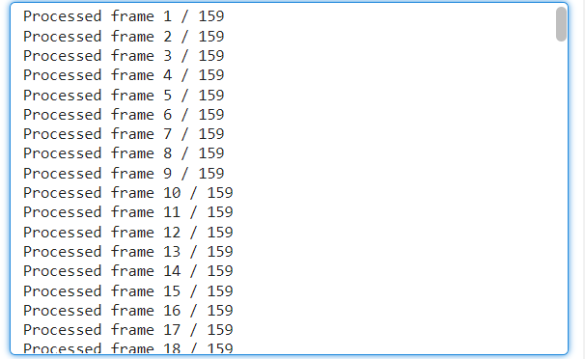

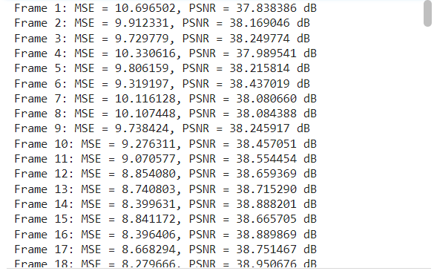

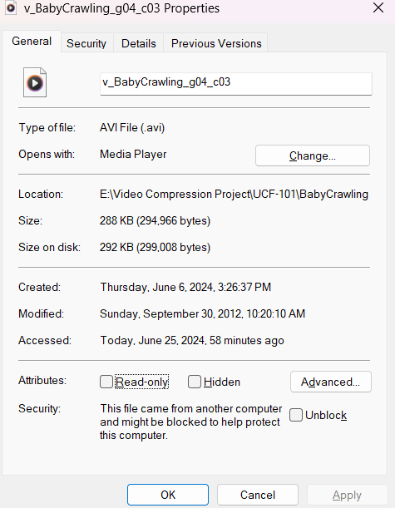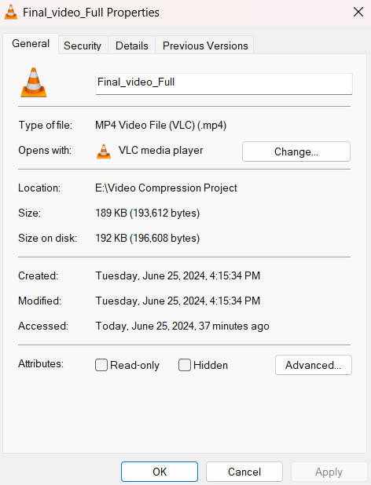

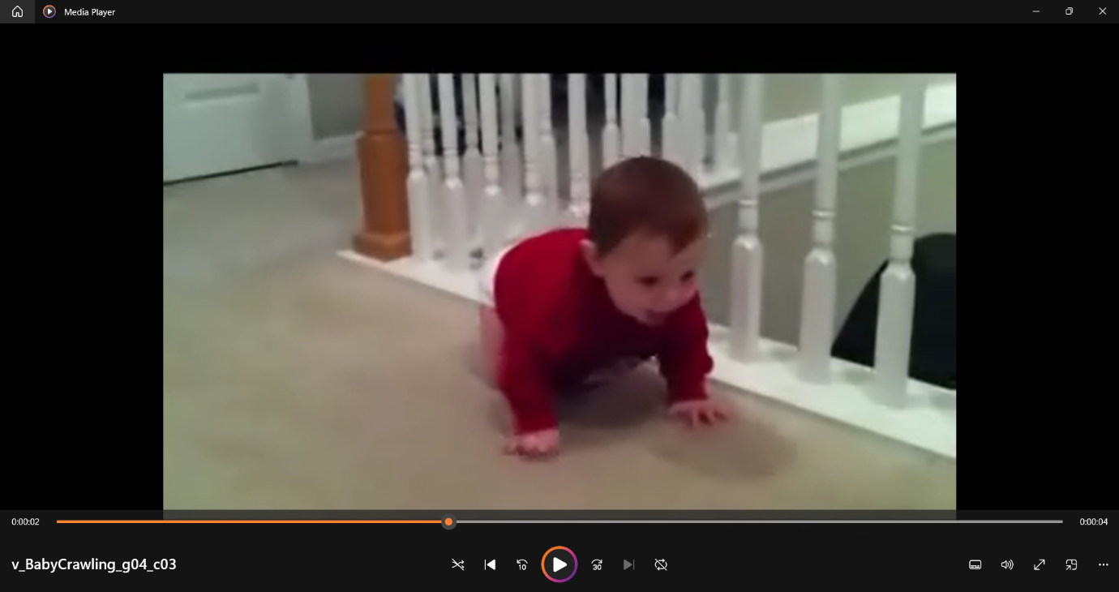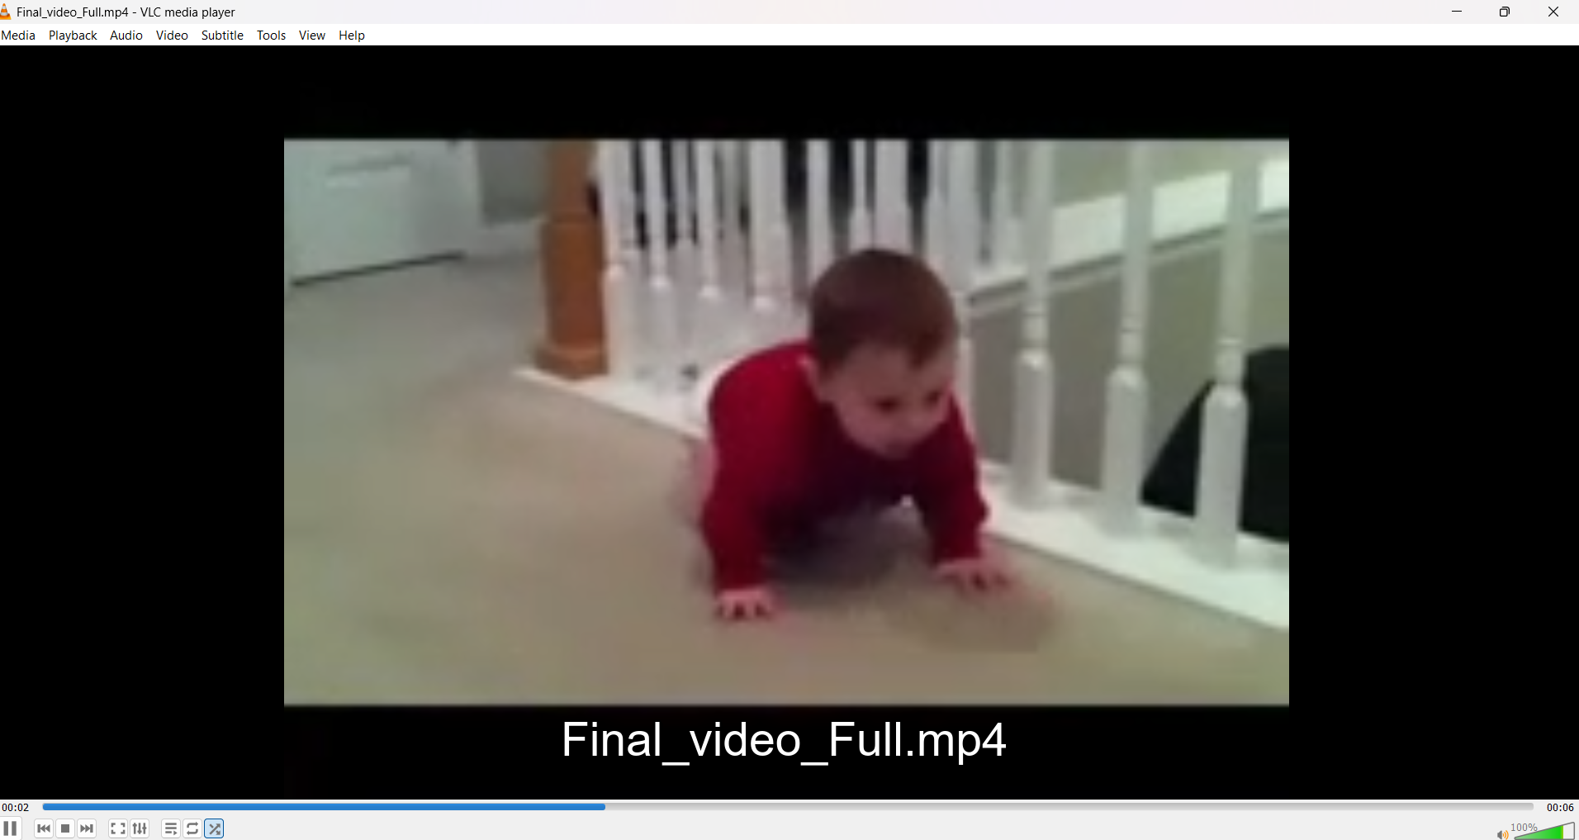

**8.0 CONCLUSION:**

In conclusion, the methodology presented for video compression in the provided code snippet showcases a comprehensive approach to enhancing storage efficiency and transmission quality of digital video content. By leveraging techniques such as quadtree decomposition, discrete cosine transform (DCT) coding, motion estimation, and advanced compression parameters, the workflow effectively reduces redundancy while preserving visual fidelity.

**Key Contributions and Findings:**

1. **Efficient Compression Techniques**: The integration of quadtree decomposition allows adaptive partitioning of frames into variable-sized blocks, optimizing the encoding process based on spatial complexity. This method not only reduces bitrate but also enhances compression efficiency by focusing computational resources on significant image regions.
2. **Motion Estimation and Compensation**: Full search motion estimation combined with DCT-based coding facilitates accurate prediction of inter-frame motion, reducing temporal redundancy. This approach improves compression ratios without compromising perceptual quality, crucial for maintaining smooth video playback and minimizing storage requirements.
3. **Quality Assessment and Enhancement**: The inclusion of quality assessment metrics such as PSNR provides quantitative measures of compression effectiveness. Techniques like non-local means denoising and aggressive resizing further refine video quality, ensuring that compressed outputs meet perceptual expectations.
4. **Practical Implementation**: The utilization of external tools like ffmpeg for audio handling and final video compilation enhances the workflow's robustness and scalability. This integration streamlines the process of combining compressed video with optimized audio, facilitating seamless multimedia content delivery.

**Future Directions:**

Moving forward, advancements in video compression methodologies are poised to benefit from emerging technologies such as deep learning-based approaches and perceptual coding techniques. These innovations promise enhanced compression efficiency and improved perceptual quality assessment, addressing challenges posed by diverse video content and evolving multimedia applications.

**Practical Implications:**

The methodology outlined in the code snippet not only demonstrates effective video compression techniques but also underscores their relevance in modern multimedia systems. From applications in digital video libraries to online streaming platforms, efficient compression workflows are essential for managing data volumes and ensuring optimal user experiences.

In essence, the methodology presented lays a solid foundation for advancing video compression standards, catering to the increasing demand for high-quality, bandwidth-efficient multimedia content across various domains. By balancing compression efficacy with perceptual quality metrics, the workflow contributes to the ongoing evolution of digital video technologies.

**9.0 References:**

[1] G. K. Wallace, “The JPEG still picture compression standard,” IEEE Trans. Consum. Electron., vol. 38, no. 1, pp. xviii–xxxiv, Feb. 1992.

[2] T. Wiegand,G. J. Sullivan,G. Bjontegaard, and A. Luthra, “Overview ofthe H.264/AVC video coding standard,” IEEE Trans. Circuits Syst. Video Technol., vol. 13, no. 7, pp. 560–576, 2003.

[3] S. Ma, T. Huang, C. Reader, andW. Gao, “AVS2? Making video coding smarter [standardsin a nutshell],” IEEE Signal Process. Mag., vol. 32, no. 2, pp. 172–183, Mar. 2015.

[4] G. J. Sullivan,J.-R. Ohm,W.-J. Han, and T. Wiegand, “Overview of the high efficiency video coding (HEVC)standard,” IEEE Trans. Circuits Syst. Video Technol., vol. 22, no. 12, pp. 1649–1668, Dec. 2012.

[5] A. Norkin et al., “HEVC deblocking filter,” IEEE Trans. Circuits Syst. Video Technol., vol. 22, no. 12, pp. 1746–1754, Dec. 2012.

[6] P. List, A. Joch, J. Lainema,G. Bjontegaard, and M. Karczewicz, “Adaptive deblocking filter,” IEEE Trans. Circuits Syst. Video Technol., vol. 13, no. 7, pp. 614–619, Jul. 2003.

[7] G. Cote, B. Erol, M. Gallant, and F. Kossentini, “H.263+: Video coding atlow bitrates,” IEEE Trans. Circuits Syst. Video Technol., vol. 8, no. 7, pp. 849–866, Nov. 1998.

[8] S.-M. Lei, T.-C. Chen, and M.-T. Sun, “Video bridging based on H.261 standard,” IEEE Trans. Circuits Syst. Video Technol., vol. 4, no. 4, pp. 425–437, Aug. 1994.

[9] L. Fan, S. Ma, and F. Wu, “Overview of AVS video standard,” in Proc. IEEE Int. Conf. Multimedia Expo (ICME), vol. 1, Jun. 2004, pp. 423–426.

[10] C.-M. Fu et al., “Sample adaptive offsetin the HEVC standard,” IEEE Trans. Circuits Syst. Video Technol., vol. 22, no. 12, pp. 1755–1764, Dec. 2012.

[11] C.-Y. Tsai et al., “Adaptive loop filtering for video coding,” IEEE J. Sel. Topics Signal Process., vol. 7, no. 6, pp. 934–945, Dec. 2013.

[12] J. Zhang, D. Zhao, and W. Gao, “Group-based sparse representation for image restoration,” IEEE Trans. Image Process., vol. 23, no. 8, pp. 3336–3351, Aug. 2014.

[13] S. Ma, X. Zhang, J. Zhang, C. Jia, S. Wang, and W. Gao, “Nonlocal in-loop filter: The way toward nextgeneration video coding?” IEEE MultiMedia, vol. 23, no. 2, pp. 16–26, Apr./Jun. 2016.

[14] X. Zhang et al., “Low-rank-based nonlocal adaptive loop filter for high-efficiency video.

compression,” IEEE Trans. Circuits Syst. Video Technol., vol. 27, no. 10, pp. 2177–2188,Oct. 2017.

[15] X. Zhang, R. Xiong, X. Fan, S. Ma, and W. Gao, “Compression artifactreduction by overlapped-block transform coefficient estimation with block similarity,” IEEE Trans. Image Process., vol. 22, no. 12, pp. 4613–4626, Dec. 2013 17.

[16] X. Zhang, W. Lin, R. Xiong, X. Liu, S. Ma, and W. Gao, “Lowrank decomposition-based restoration of compressed images via adaptive noise estimation,” IEEE Trans. Image Process., vol. 25, no. 9, pp. 4158– 4171, Sep. 2016.

[17] X. Zhang, R. Xiong, W. Lin, S. Ma, J. Liu, and W. Gao, “Video compression artifact reduction via spatio-temporal multi-hypothesis prediction,” IEEE Trans. Image Process., vol. 24, no. 12, pp. 6048–6061, Dec. 2015.

[18] Y. LeCun, Y. Bengio, andG. Hinton, “Deep learning,” Nature, vol. 521, no. 7553, pp. 436–444, May 2015.

[19] K. Zhang,W. Zuo, Y. Chen, D. Meng, and L. Zhang, “Beyond aGaussian denoiser: Residual learning of deep CNN for image denoising,” IEEE Trans. Image Process., vol. 26, no. 7, pp. 3142–3155, Jul. 2017.

[20] C. Dong, Y. Deng, C. C. Loy, and X. Tang, “Compression artifactsreduction by a deep convolutional network,” in Proc. IEEE Int. Conf. Comput. Vis., Dec. 2015, pp. 576–584.

[21] J. Ballé, V. Laparra, and E. P. Simoncelli. (2016). “End-to-end optimized image compression.” [Online]. Available: https://arxiv. org/abs/1611.01704 .

[22] N. Yan, D. Liu, H. Li, and F. Wu. (2017). “A convolutional neural network approach for half-pel interpolation in video coding.” [Online]. Available: <https://arxiv.org/abs/1703.03502>.

[23] J. Liu, S. Xia,W. Yang, M. Li, and D. Liu, “One-for-all: Grouped variation network-based fractional interpolation in video coding,” IEEE Trans. Image Process., vol. 28, no. 5, pp. 2140–2151, May 2019.

[24] Y. Wang, X. Fan, C. Jia, D. Zhao, and W. Gao, “Neural network based inter prediction for HEVC,” in Proc. IEEE Int. Conf. Multimedia Expo (ICME), Jul. 2018, pp. 1–6.

[25] Y. Dai,D. Liu, and F. Wu, “A convolutional neural network approach for post-processing in HEVC intra coding,” in Proc. Int. Conf. Multimedia Modeling. Reykjavik, Iceland: Springer, 2017, pp. 28–39.

[26] C. Jia, S. Wang, X. Zhang, S. Wang, and S. Ma. (2017). “Spatialtemporal residue network based inloop filter for video coding.” [Online]. Available: <https://arxiv.org/abs/1709.08462>.

[27] C. Szegedy et al., “Going deeper with convolutions,” in Proc. IEEE Conf. Comput. Vis. Pattern Recognit., Jun. 2015, pp. 1–9.

[28] B. Ramamurthi and A. Gersho, “Nonlinear space-variant postprocessing of block coded images,” IEEE Trans. Acoust., Speech, Signal Process., vol. 34, no. 5, pp. 1258–1268, Oct. 1986.

[29] S. D. Kim,J. Yi, H. M. Kim, andJ. B. Ra, “A deblocking filter with two separatemodes in block-based video coding,” IEEE Trans. Circuits Syst. Video Technol., vol. 9, no. 1, pp. 156–160, Feb. 1999.

[30] H. Jo, S. Park, andD. Sim, “Parallelized deblocking filtering ofHEVC decoders based on complexity estimation,” J. Real-Time Image Process., vol. 12, no. 2, pp. 369–382, 2016.